PNG

📘 Definition
# Source: AI Source: Provided by: [Data Path: Persons Table -> ID Column: 1, Name_En Column: Motasem Essam] -> From: [ChatGPT] on [5/2/2026]
PNG (Portable Network Graphics) is a digital image file format used to store images with high quality and transparent backgrounds.
Unlike JPG, PNG uses lossless compression, which means it does not lose image quality when saved.

🌐 How PNG works
# Source: AI Source: Provided by: [Data Path: Persons Table -> ID Column: 1, Name_En Column: Motasem Essam] -> From: [ChatGPT] on [5/2/2026]
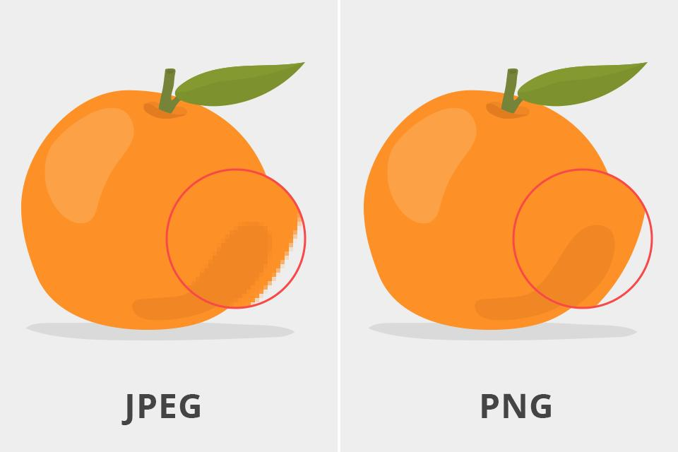
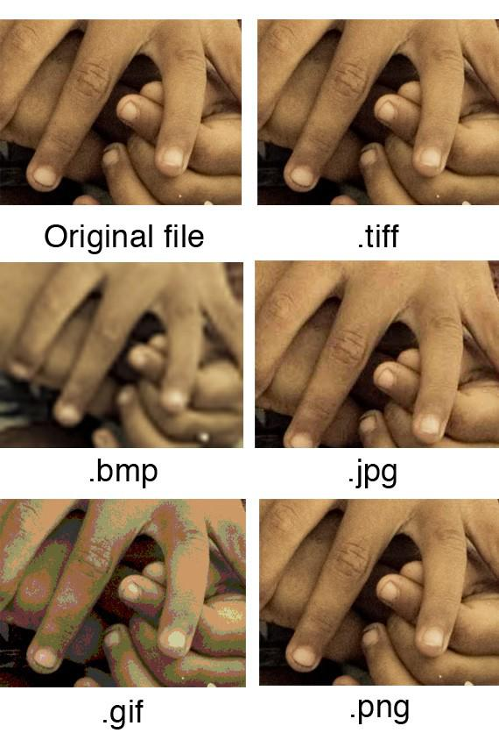

- PNG keeps all image details using lossless compression
- It supports transparent backgrounds (no background color)
- Works best for graphics with sharp edges and text
- Maintains high image quality

🧠 Simple example
# Source: AI Source: Provided by: [Data Path: Persons Table -> ID Column: 1, Name_En Column: Motasem Essam] -> From: [ChatGPT] on [5/2/2026]
Think of:
- 🌐 A logo on a website with no background
- 🎮 Game UI icons (health bar, buttons)
- 🖼️ Stickers or images that can be placed on any background
These are often PNG images.

🎮 Where PNG is used
# Source: AI Source: Provided by: [Data Path: Persons Table -> ID Column: 1, Name_En Column: Motasem Essam] -> From: [ChatGPT] on [5/2/2026]
- 🌐 Web design (logos, icons, UI elements)
- 🎨 Graphic design
- 🧑‍💻 App interfaces
- 🖼️ Images requiring transparency

⚙️ Key features
# Source: AI Source: Provided by: [Data Path: Persons Table -> ID Column: 1, Name_En Column: Motasem Essam] -> From: [ChatGPT] on [5/2/2026]
- 🟢 No quality loss (lossless format)
- 🧊 Supports transparent backgrounds
- ✨ Sharp edges and clear text
- 📁 Larger file size than JPG

🚀 In short:
# Source: AI Source: Provided by: [Data Path: Persons Table -> ID Column: 1, Name_En Column: Motasem Essam] -> From: [ChatGPT] on [5/2/2026]
PNG = a high-quality image format that supports transparency and does not lose image quality when saved.

